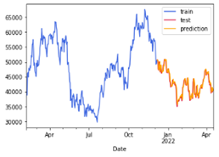

Train

Test

Prediction

Close



